220801140

**EX. NO:**

**DATE :**

10

11/05/2024

# K-NN classifier to predict signal quality based on distance from the transmitter, signal strength, and frequency

**AIM:**

To classify signal quality based on various parameters such as distance from the transmitter, signal strength, and frequency.

**PROGRAM:**

import numpy as np import pandas as pd import matplotlib.pyplot as plt from sklearn.model_selection import train_test_split from sklearn.neighbors import KNeighborsClassifier from sklearn.preprocessing import StandardScaler from sklearn.metrics import accuracy_score, classification_report, confusion_matrix import seaborn as sns

# Example dataset: Distance (meters), Signal Strength (dBm), Frequency (MHz) vs. Signal Quality data = {

'Distance': [1, 2, 3, 4, 5, 6, 7, 8, 9, 10, 2, 3, 4, 5, 6],

'Signal_Strength': [-30, -35, -40, -45, -50, -55, -60, -65, -70, -75, -33, -38, -43, -48, -53],

'Frequency': [850, 850, 850, 850, 850, 1900, 1900, 1900, 1900, 1900, 850, 850, 1900, 1900, 1900],

'Signal_Quality': ['Good', 'Good', 'Good', 'Good', 'Bad', 'Bad', 'Bad', 'Bad', 'Bad', 'Bad', 'Good', 'Good', 'Bad', 'Bad', 'Bad'] }

# Convert the data into a DataFrame df = pd.DataFrame(data)

# Separate features and target variable

X = df[['Distance', 'Signal_Strength', 'Frequency']].values # Features y = df['Signal_Quality'].values # Target

# Encode the target variable

from sklearn.preprocessing import LabelEncoder le = LabelEncoder() y = le.fit_transform(y) # 'Good' -> 1, 'Bad' -> 0

220801140

# Split the data into training and testing sets

X_train, X_test, y_train, y_test = train_test_split(X, y, test_size=0.2, random_state=42)

# Standardize the features scaler = StandardScaler()

X_train = scaler.fit_transform(X_train)

X_test = scaler.transform(X_test)

# Create and train the k-NN classifier k = 3 # Number of neighbors model = KNeighborsClassifier(n_neighbors=k) model.fit(X_train, y_train)

# Make predictions y_pred = model.predict(X_test)

# Evaluate the model accuracy = accuracy_score(y_test, y_pred) report = classification_report(y_test, y_pred, target_names=['Bad', 'Good'])

print(f'Accuracy: {accuracy:.2f}') print('Classification Report:') print(report)

# Confusion Matrix conf_matrix = confusion_matrix(y_test, y_pred) sns.heatmap(conf_matrix, annot=True, fmt='d', cmap='Blues', xticklabels=['Bad', 'Good'], yticklabels=['Bad', 'Good']) plt.xlabel('Predicted') plt.ylabel('Actual') plt.title('Confusion Matrix') plt.show()

220801140

**OUTPUT :**

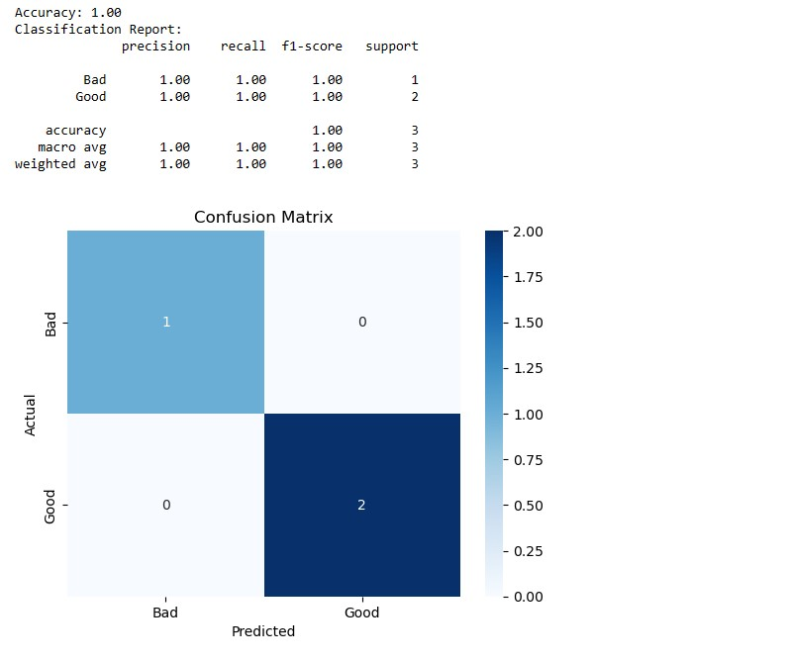

**RESULT:**

Hence the signal quality is classified based on various parameters using K-NN classifier.